**Object Oriented Programming**

**Lab Journal - Lab # 1**

Name: Saad Ahmad

Enrollment #: 01-134222-130

Class: BS-CS-2A

**Objective**

This lab will cover recap of C++ concepts including built-in functions, function pass by value, overloaded functions and function pass by reference.

**Exercise 1 : Write output of the following tasks.**

|  |  |  |
| --- | --- | --- |
| 1. | cout << time(0); | **Output:**  1677173552 |
| 2. | int anyRandomNumber1 = rand();  int anyRandomNumber2 = rand();  int anyRandomNumber3 = rand();  cout << anyRandomNumber1<<endl;  cout << anyRandomNumber2<<endl;  cout << anyRandomNumber3 << endl; | 41  18467  6334 |
| 3. | //In the range 0 to 9  int anyRandomNumber1 = rand()%10;  int anyRandomNumber2 = rand()%10;  int anyRandomNumber3 = rand()%10;  cout << anyRandomNumber1<<endl;  cout << anyRandomNumber2<<endl;  cout << anyRandomNumber3 << endl; | 1  7  4 |
| 4 | //In the range 1 to 10  int anyRandomNumber1 = rand()%10 + 1;  int anyRandomNumber2 = rand()%10 + 1;  int anyRandomNumber3 = rand()%10 + 1;  cout << anyRandomNumber1<<endl;  cout << anyRandomNumber2<<endl;  cout << anyRandomNumber3 << endl; | 2  8  5 |
| 5. | Execute the following code twice and observe the output.  int seed = 20;  srand(seed);  int anyRandomNumber1 = rand() % 10 + 1;  int anyRandomNumber2 = rand() % 10 + 1;  int anyRandomNumber3 = rand() % 10 + 1;  cout << anyRandomNumber1 << endl;  cout << anyRandomNumber2 << endl;  cout << anyRandomNumber3 << endl; | 4  10  4  4  10  4 |
| 6. | Change the statement srand(seed) to srand(time(0)) and execute the program twice. observe the output. how this output is different than the above point. | 3  5  4 |

**#include<math.h>**

|  |  |  |
| --- | --- | --- |
| 7. | int distanceAtoB = 560;  int distanceAtoC = 730;  int distanceBtoC = distanceAtoB - distanceAtoC;  cout << distanceBtoC<<endl;    distanceBtoC = abs(distanceBtoC);  cout << distanceBtoC<<endl; | -170  170 |
| 8. | int cube = pow(2, 3);  cout << cube; | 8 |
| 9. | float theta = 45;  cout << cos(theta) << endl;  cout << sin(theta) << endl;  cout << tan(theta) << endl; | 0.525322  0.850904  1.61978 |
| 10. | float number = 29.5;  cout << ceil(number) << endl;  cout << floor(number) << endl; | 30  29 |

**Exercise 2**

Write a program which computes the following expression.

F= (x * yn)/z!

Take input of x, y, and z from user. Pass these values into a function to compute this expression. In case of negative values, provide default values for these variables. Display the value of “F” in main().

**Code :**

#include <iostream>

#include <math.h>

using namespace std;

int factorial(int a) {

int multiply = 1;

while (a > 1) {

multiply = multiply * a;

a--;

}

return multiply;

}

float formula(int a = 1, int b = 1, int c = 1, int q = 1) {

if (a < 0) {

a = 1;

}

if (b < 0) {

b = 1;

}

if (c < 0) {

c = 1;

}

c = factorial(c);

float F = (a * pow(b, q)) / c;

return F;

}

int main() {

int x, y, z, n;

cout << "Enter the value of x" << endl;

cin >> x;

cout << "Enter the value of y" << endl;

cin >> y;

cout << "Enter the value of z" << endl;

cin >> z;

cout << "Enter the value of n" << endl;

cin >> n;

if (n < 0) {

cout << formula(x, y, z);

}

else {

cout << formula(x, y, z, n);

}

return 0;

}

**Output :**

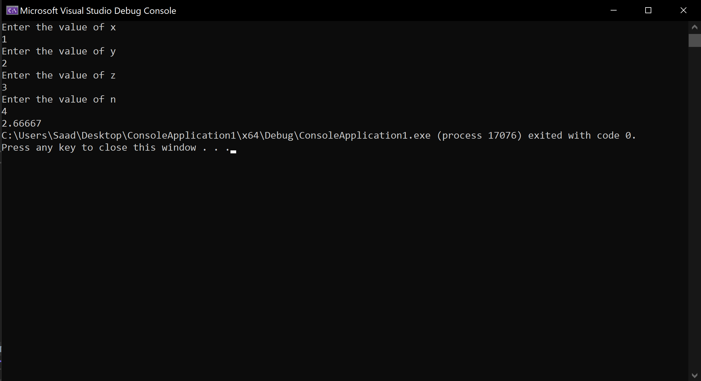

**Exercise 3**

Write a function to convert temperature from Fahrenheit to Celsius. Ask the user to enter temperature in degree Fahrenheit and then convert it to Celsius using a function.

Celsius=(F-32)*(5/9).

*Hint: 5/9 = 0.5555, if you want to use division operator, you may need to perform typecasting into double.

Code:

#include <iostream>

using namespace std;

double convert(int temp) {

double cel = (temp - 32) * (0.55555);

return cel;

}

int main() {

int temp;

cout << "Enter temperature in Fahrenheit : " << endl;

cin >> temp;

cout << "Temperature in Celsius : " << convert(temp);

return 0;

}

Output:

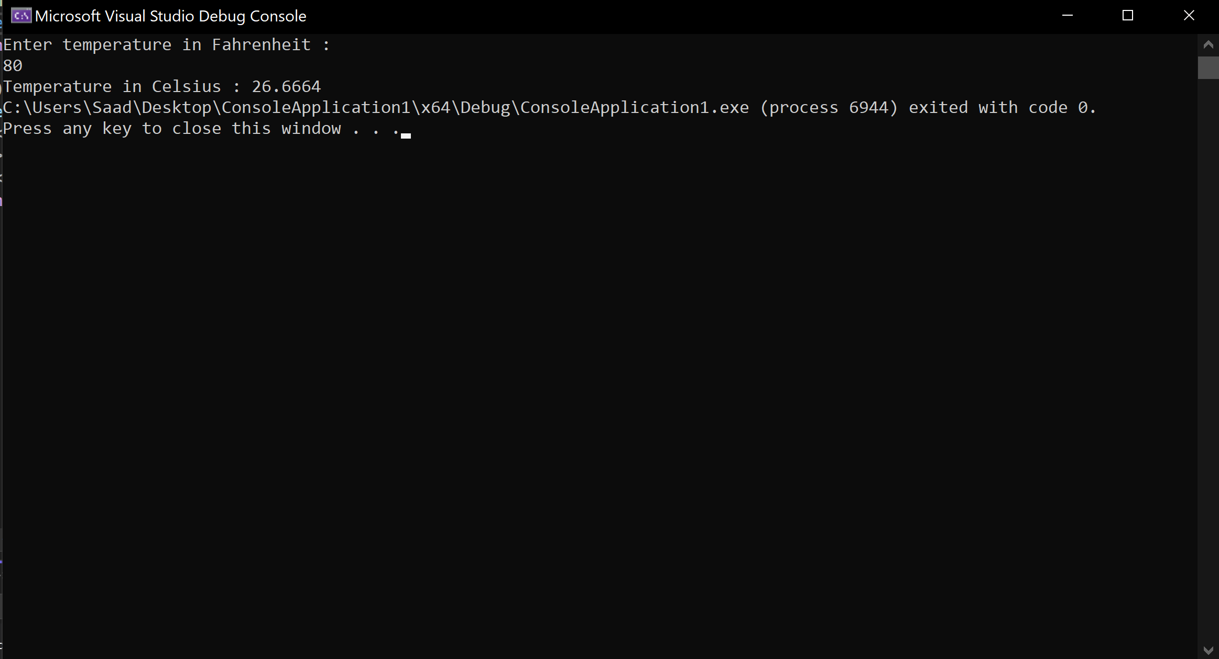

**Exercise 4**

Write a function to print fibnocci series till the limit provided by user

Code:

#include <iostream>

using namespace std;

int main() {

int limit;

cout << "Enter the limit" << endl;

cin >> limit;

int arr[2] = { 0,1 };

cout << arr[0] << " " << arr[1] << " ";

int sum = 0;

for (; sum < limit;) {

sum = arr[0] + arr[1];

arr[0] = arr[1];

arr[1] = sum;

if (sum < limit) {

cout << sum << " ";

}

else {

break;

}

}

return 0;

}

Output:



